Joining a Zoom meeting
N.B. This process will be quicker if you have already Set Zoom up on your computer / tablet / phone. Please see the ‘Instructions for setting up Zoom on your computer, tablet or phone’ for how to do this
Before the meeting is due to start, the administrator will send you an invitation by email that looks like this:
Click on the link:
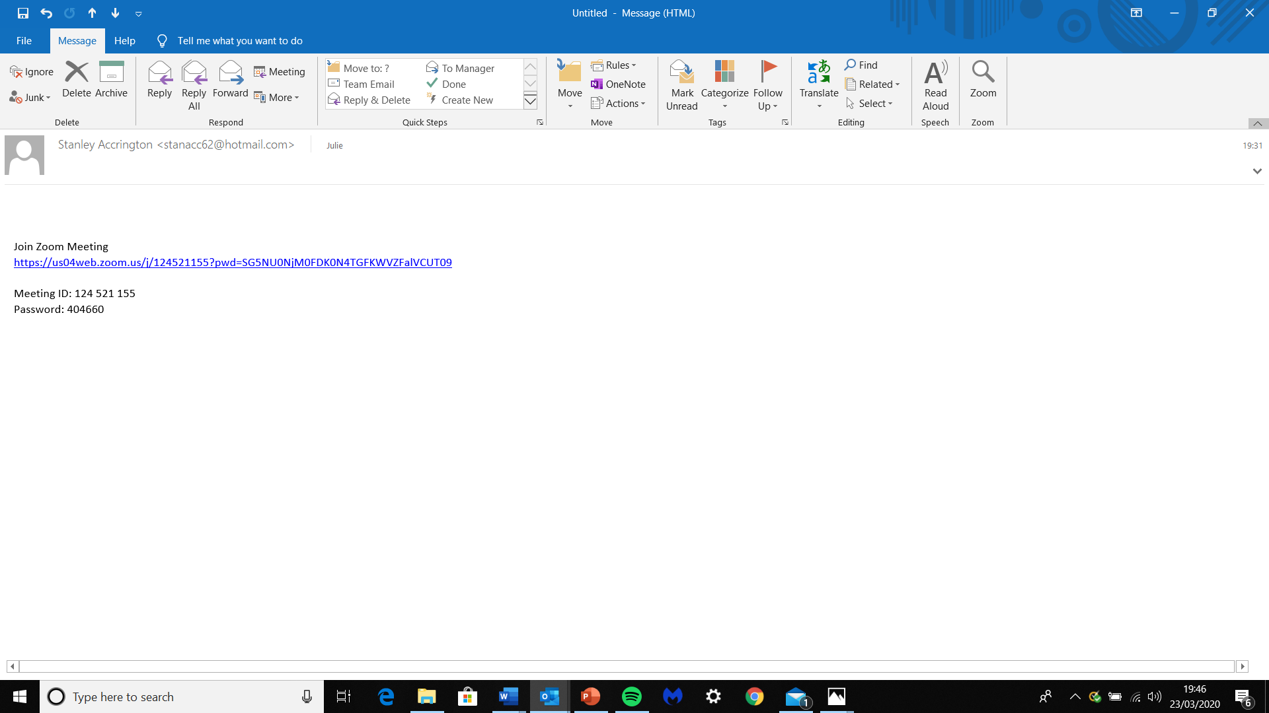

That will take you to this page. Sometimes it starts straight away, but you may need to click on ‘Open Zoom’ If that doesn’t work, try clicking here
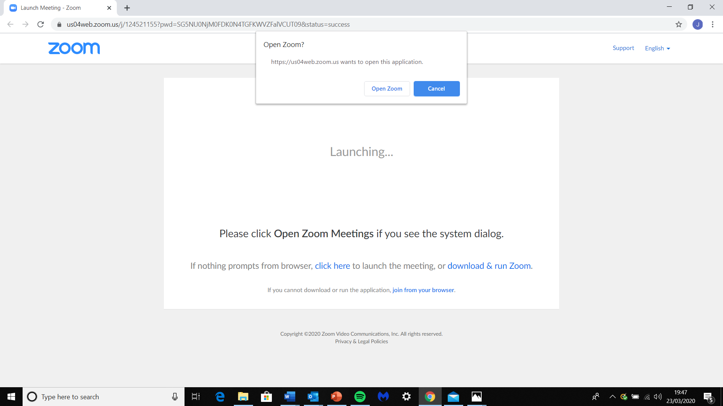

You will then be able to see yourself on screen
Zoom will then ask you if you want to join with or without video – Click the blue box
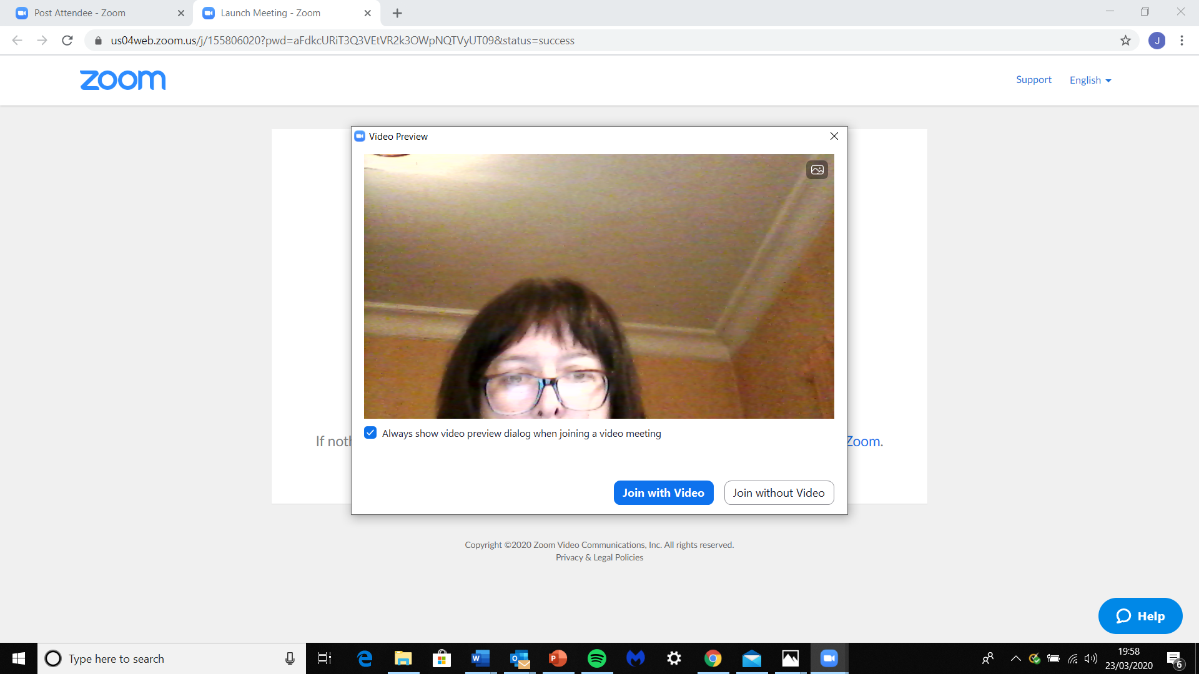
You will then start to see the other people in the meeting
Zoom will ask if you want to join with or without Computer Audio
Click the blue box
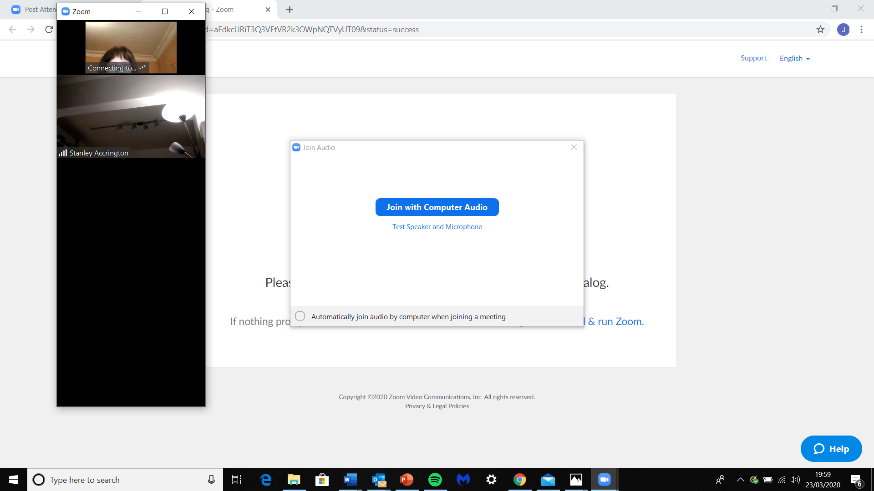
Then you can enlarge the picture of yourself and everyone else so it fills the screen, by clicking here

Once you have joined the meeting….
The most important things you need to know are all on the bottom tool bar
For a big group, it’s really important that everyone presses the ‘Mute’ button unless they are talking. Otherwise everyone will be able to hear everything that is going on in the background in everyone’s houses
The Mute button is here (It looks like a microphone)
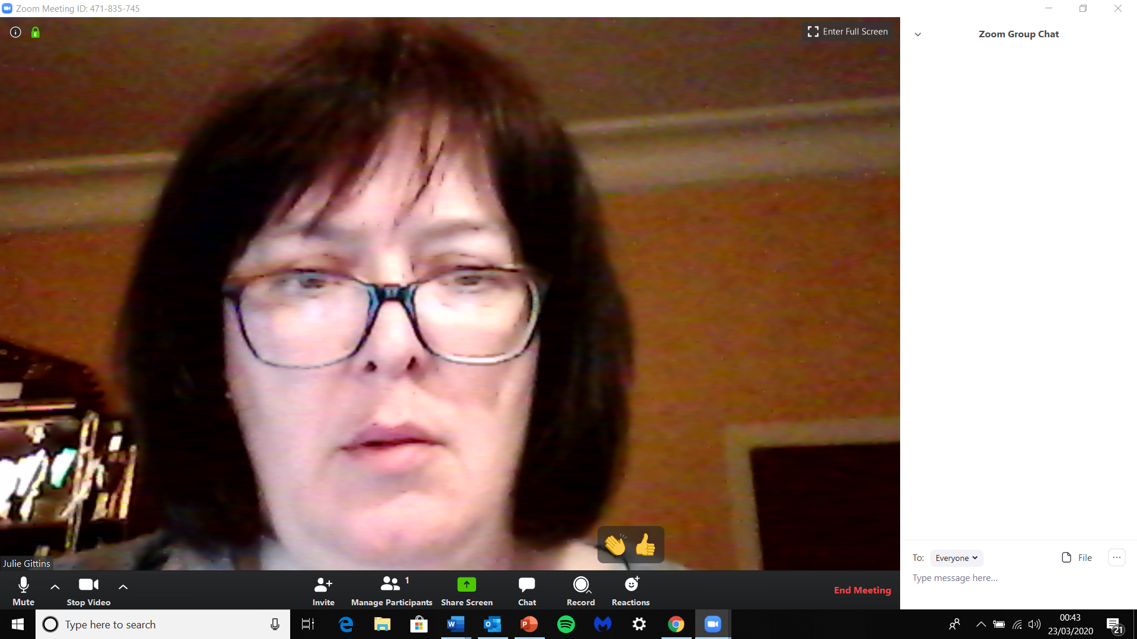
If you don’t want people to see you, you can click the ‘Stop video’ button here. (It looks like a video camera). You will still be able to see and hear everyone else and they will be able to hear you
As people join, you’ll be able to see them all on little screens across the top or side of your screen. The screen can only show about 6 at a time, so if there are more than that, an arrow will appear so you can scroll from right to left
The microphone picks up people’s voices, and puts the person who is talking onto big screen in the middle. (That’s why it’s important that everyone else is on ‘Mute’)
If you want to comment, you can click on the ‘Chat’ button at the bottom, and write a comment
The Chat button is here,
You can either send the message to everyone or to one person
Your message will appear in the white box at the side of the screen.

If you want to get the administrator’s attention, you can give a ‘Wave’ by clicking the ‘Reactions’ button, here You can also give a ‘Thumbs up’

