**Using Zoom**

Zoom is a programme that allows lots of people to have on-line meetings or gatherings at the same time – to see and talk to each other. You can use it on a Smart phone, a tablet or a computer, as long as the device has a camera and a microphone (most of them do 😊). They all work, but the bigger the screen, the easier it is to see everyone, so laptops and tablet are a bit better than phones for big groups.

One person, the administrator, sets up the meeting. A few minutes before the meeting is due to start, the administrator sends an email to everyone they are inviting. The email will have an internet link; each person needs to click on to join the meeting.

**Setting Zoom up**

The first time you use Zoom, you need to install it on your device. If you are confident using a computer, then you can either upload the App or just follow the instructions the first time you join a meeting and it will do it automatically.

But if you’re not too confident, it’s better to set it up before the meeting starts - this will take a few minutes. On the next pages are instructions for setting up Zoom on a PC / Laptop / Tablet, and then separate instructions for setting up on a phone.

***Please note – all the screen shots are from my Microsoft laptop and my Apple iPhone. The screens might look different if you have a different type of device, but they should be similar enough that you are able to follow the steps.***

**Installing Zoom on a PC / Tablet (Installing on your phone comes later)**

Start by searching for [www.zoom.us](http://www.zoom.us/) on the internet. The front page looks like this:

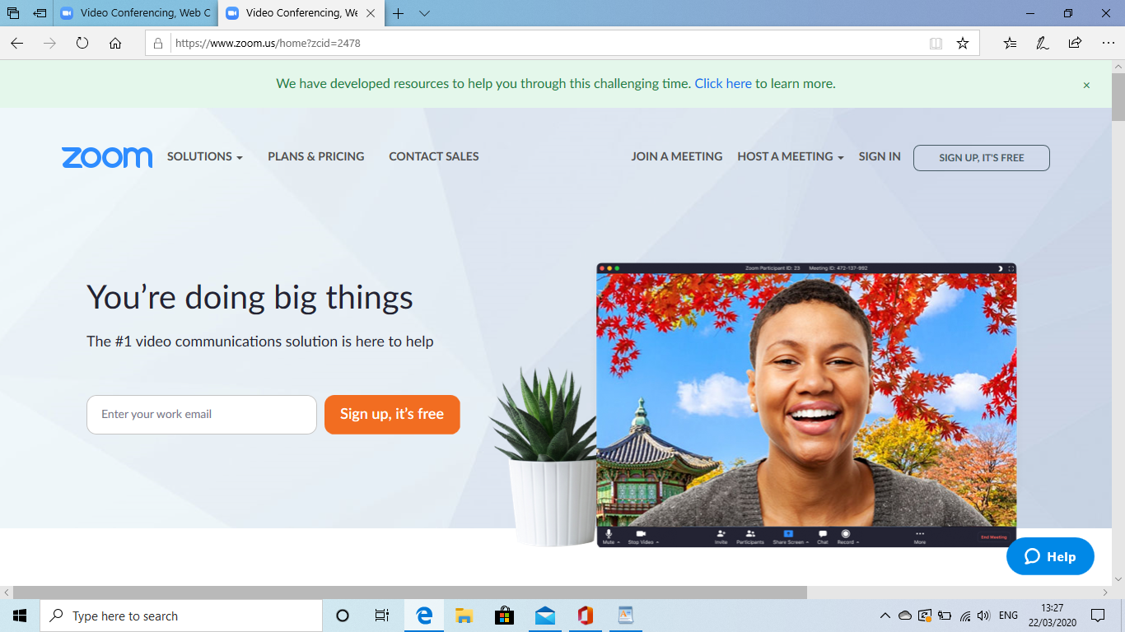

Click onto 'Sign up, it's free' in the top right hand corner

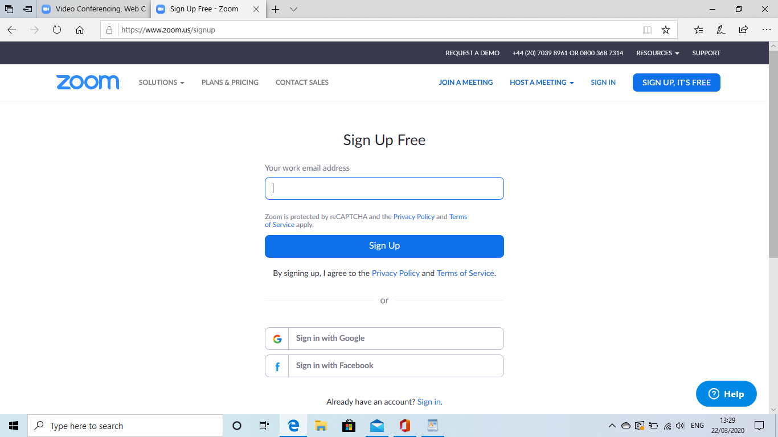

Enter your email address (it doesn't have to be a work email 😊)

Zoom will then show this screen to tell you it has sent you an email: 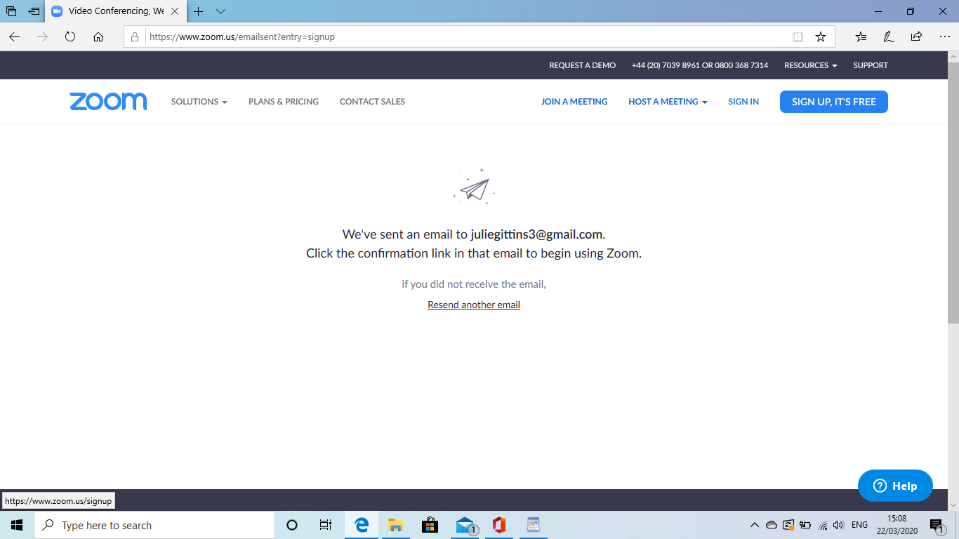

You will then need to go back to your email and click on the link that they have sent you

If an email doesn't arrive first time, it will ask you to click to send it again. It will then ask you to tick to confirm that you are not a robot :-)

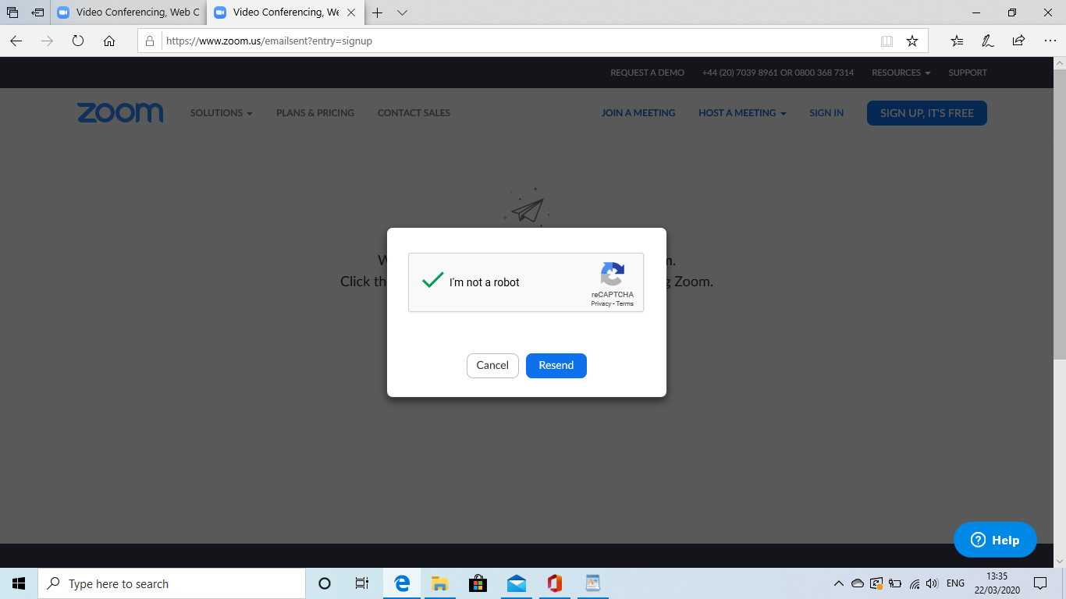

The email message will look like this:

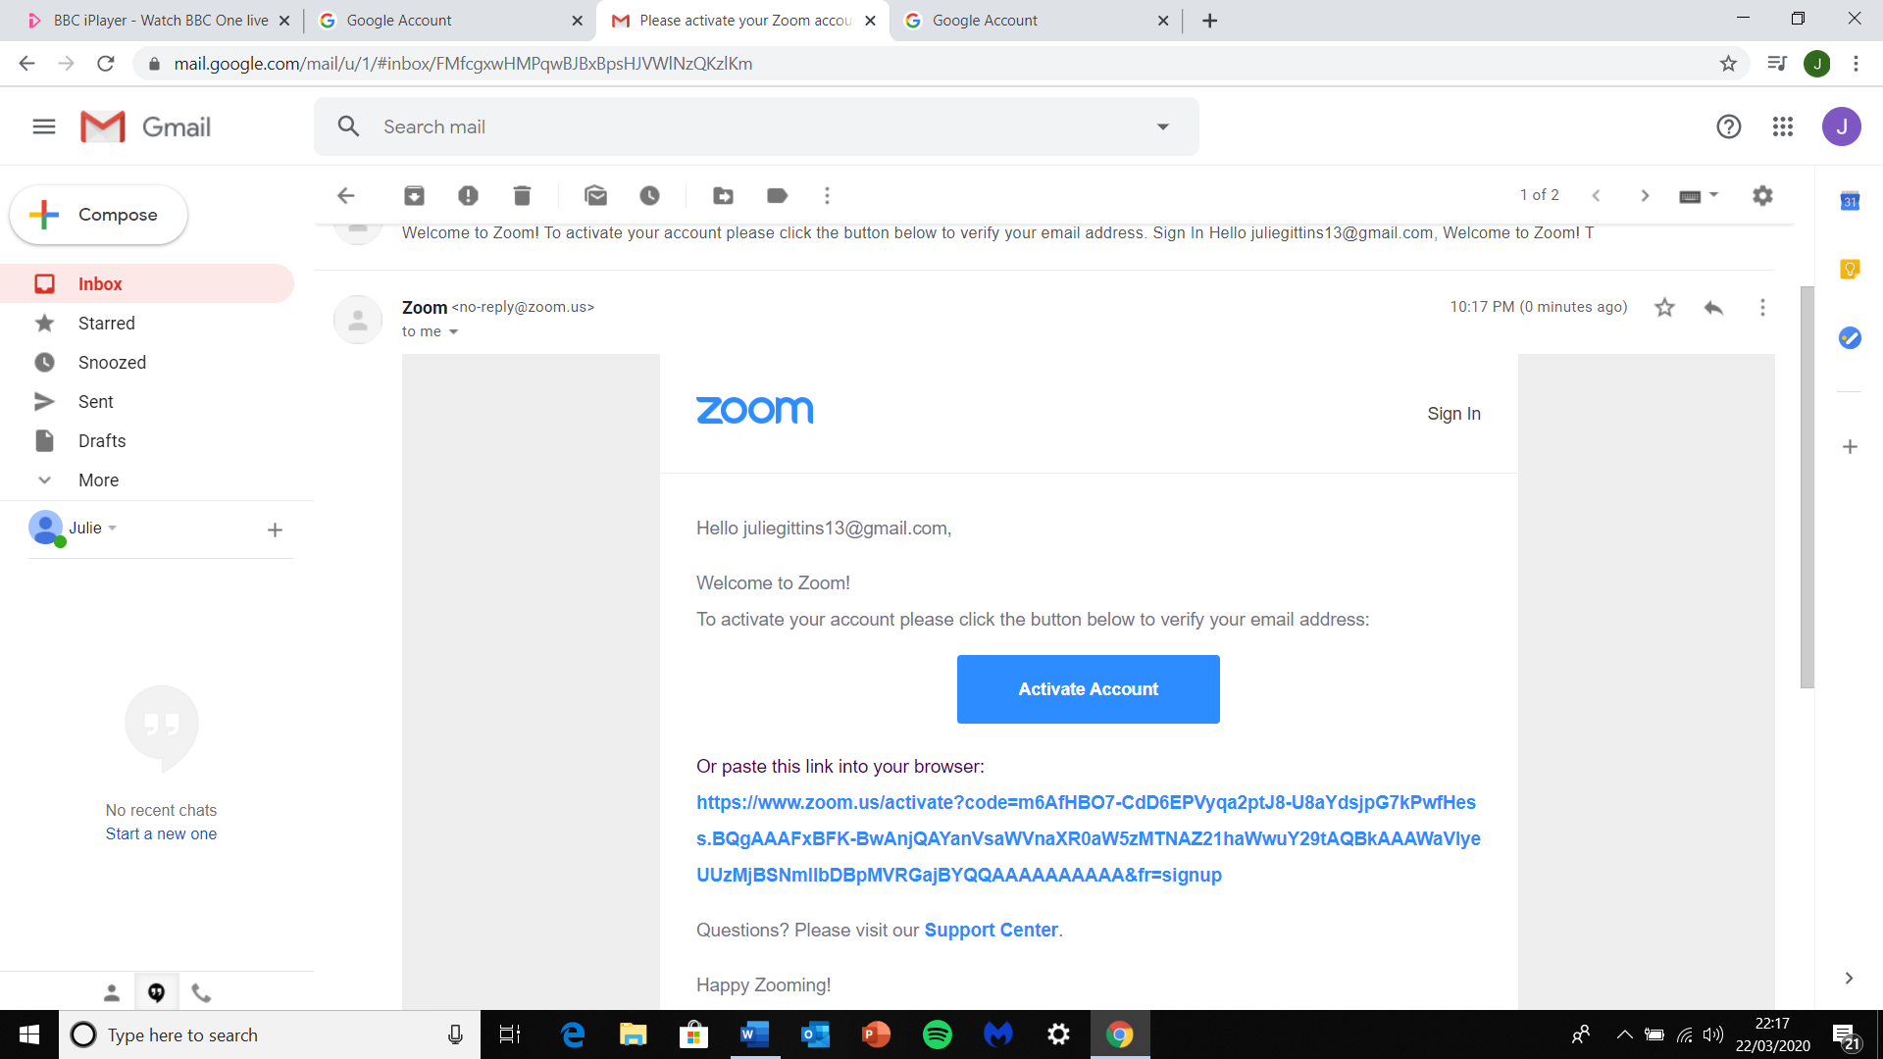

Open the email and click on the blue 'Activate Account' button

Then go back to the Zoom page (it may do this automatically)

There will be a page that says 'Welcome to Zoom'

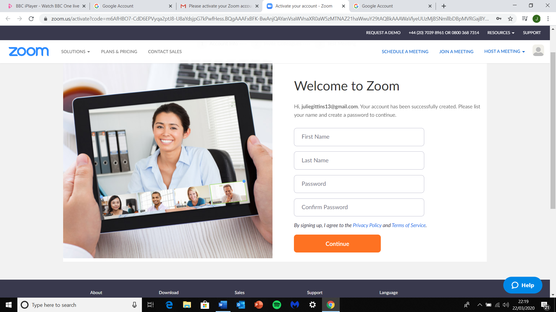

You need to fill in your first and last name

Then create a password. It’s good if the password has letters and numbers.

It will ask you to confirm the password by typing it in again

Then click the Orange 'Continue' button

Zoom will then ask if you want you to invite your colleagues. You can ignore this bit.

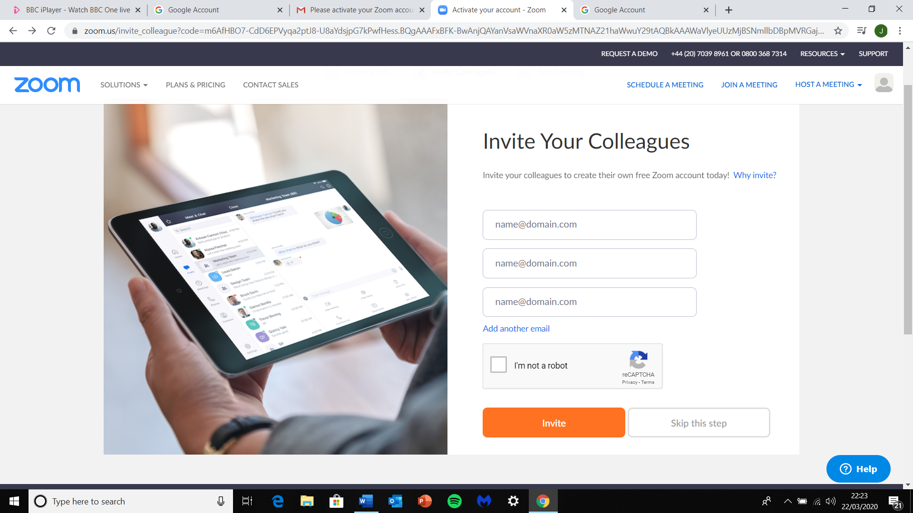

Click the 'I'm not a robot' box,

Then the 'Skip this step' box

That's it!

It will say 'Start your test meeting’, but you don't need to do anything more at this stage.

You just need to wait for the email to ask you to join the meeting 😊

**Installing Zoom on your phone**

***Please note – the screen shots are from my Microsoft laptop. The screens might look different if you are on an Apple or a tablet, but they should be similar enough that you are able to follow the steps. If you have a problem, call me on 07765 527358 😊***

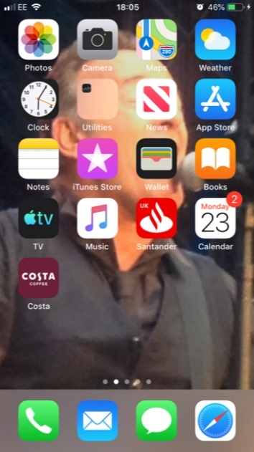

First find the App store on your screen and click on it

(On an Android phone, it’s called Google Play)



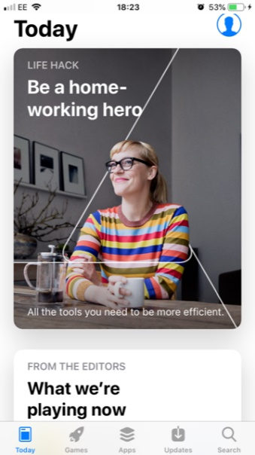

The next screen will look different on different phones, but it doesn’t matter. What you want is the ‘Search’ icon (Magnifying glass) at the bottom. Click on that.

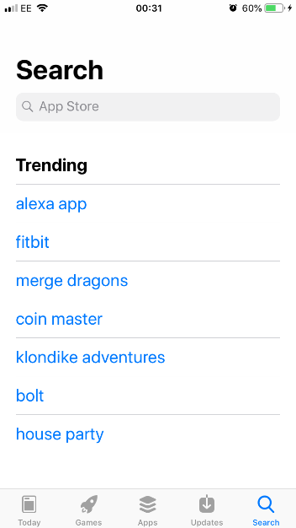

Type ‘Zoom’ into the space at the top and then click the blue ‘Search’ button at the bottom of the keyboard

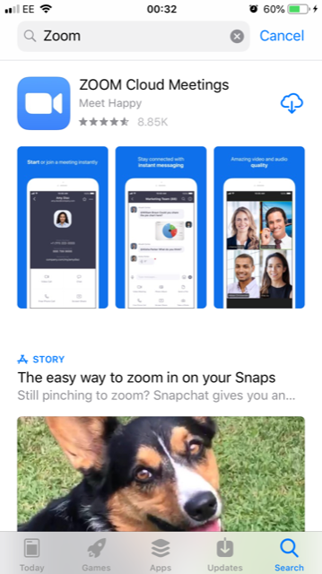

The Zoom page will look like this. Click on the little cloud in the top right hand corner. It will take a few minutes to download. It’s free.

Once it’s ready, click ‘Open’.



You’ll see this screen for a couple of seconds

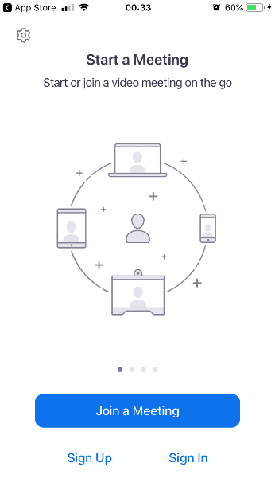

When you see this screen, click ‘Sign Up’ on the bottom left

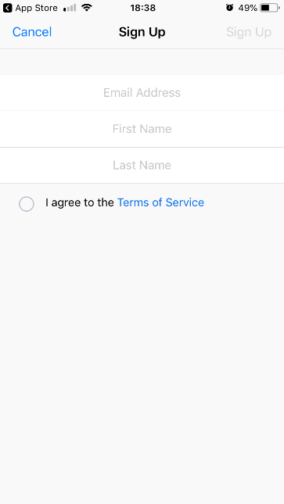

It will ask you to enter an email address, plus your first and last name, and then agree to the Terms of Service

Then click ‘Sign Up’ at the top right of the screen

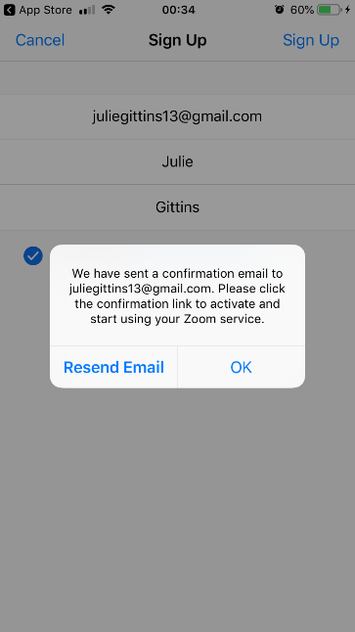

It will then tell you they have sent a confirmation email to you. From here, you can follow the steps for the Laptop (from the beginning of the 2nd page). The screens might look slightly different, but the process will be very similar

You’ll need to create a Password.