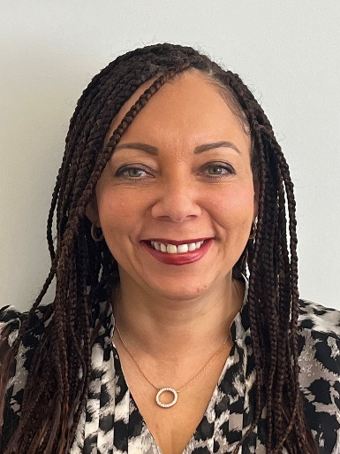 | 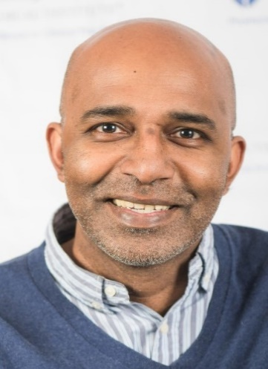 | 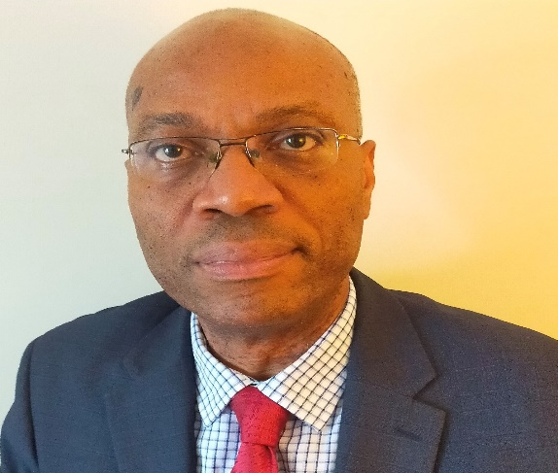
Patricia Miller OBE  Chair  Dorset ICB & NHS Race & Health Observatory | Anton Emmanuel  Interim Director of Equality, Diversity and Inclusion  NHS England and NHS Improvement | Ade Adetukasi  Associate Director of Employee Experience & Organisational Development  Norfolk and Suffolk Foundation Trust
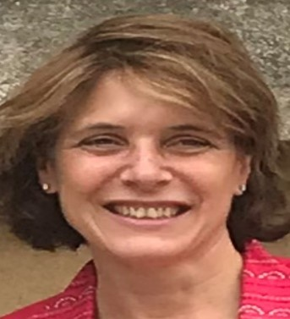 | 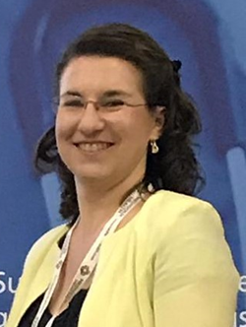 | 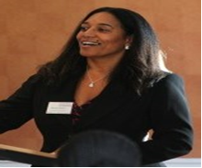
Dr Katy Steward  Head of Culture Transformation  NHS England and NHS Improvement | Louise Pramas  Transformation Lead  NHS England and NHS Improvement | Morvia Gooden  Transformation Lead  NHS England and NHS Improvement

