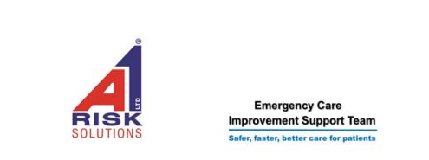

South East Single Handed Care Event
Wednesday 21st September 2022
Proposed agenda

09.30 | Registration in the Royal Suite Lobby | NHS England
10.00 | Welcome | Jo Richardson Improvement Manager Therapies, ECIST
10.15 | Introduction to Single handed Care | Deborah Harrison  A1 Risk solutions
11.30 | BREAK – Tea and Coffee will be available
11.45 | Introduction to equipment suppliers
12.00 | Practical Workshop | 20 minutes at each station
13.00 | Lunch | Retrouve Restaurant
13.30 | Stakeholder and Solutions workshop
14.45 | BREAK
15.00 | Tools, Hearts, Minds and Actions
16.30 | Finish

Please note that timings may vary slightly but we will endeavour to keep as close to this schedule as possible.

