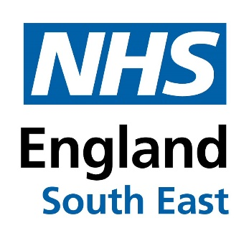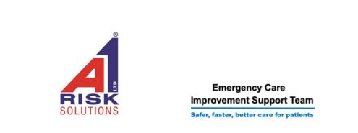
South East Single Handed Care Event
Wednesday 21st September 2022
This event is delivered by A1 Risk Solutions and hosted by NHS South East. It will help you to explore the benefits, implementation and barriers to Single Handed Care and provide opportunity to gain hands on experience of equipment available to support the approach. Single Handed Care is known to have may benefits to organisations, service users and staff including improved flow through organisations and systems, with Service Users being more likely to return home and a reduction in deconditioning.

Venue The Royal Suite,
Copthorne Hotel Slough / Windsor
Cippenham Lane,
Slough,
Berkshire
SL1 2YE

Web address Copthorne Hotel Slough-Windsor
Telephone 01753 516222
Car parking Free parking available on site

Closest station Slough (0.7 Miles)
Windsor and Eton Riverside (1.4 Miles)
Windsor and Eton Central (1.6 Miles)

Refreshments Lunch and Tea and Coffee will be provided
Please advise if you have any dietary requirements at the time of booking your place on NHS Events or email donna.harrison16@nhs.net and Darren.Plank@nhs.net

Accessibility Access Category 1 - Unassisted wheelchair access for delegates
Access Category 2 - Assisted wheelchair access for delegates
Access Category 3 - Access for delegate with mobility difficulties

