An event to learn about different ways to look after your mind that are not medication, and if you need medication how to make sure it is right for you. This event is ran by the national STOMP and STAMP team.
Getting medicine right for people- an event for people and families
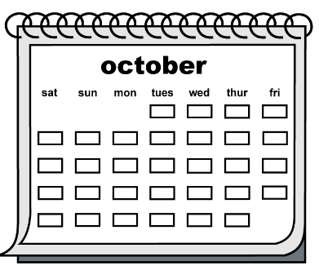 | Date and time: Thursday the 26th January, between 10:00 am to 3:30 pm
 | How we will hold the event: The event will be on Microsoft Teams. We will send everyone who wants to attend a guide on how to use Microsoft teams and will have IT support on the day.
 | The event is for: autistic people and people with a learning disability of all ages, and their families and carers.
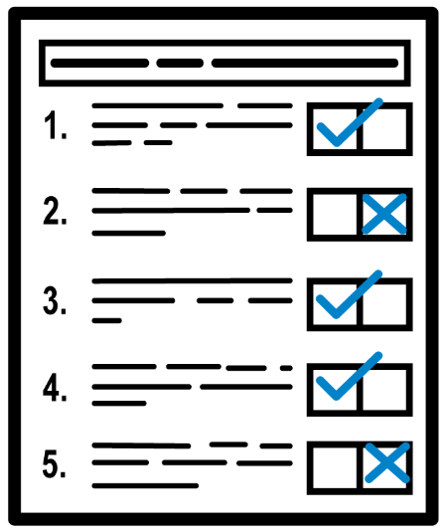 | If you would like to come to this event, please fill in the form below and email it to england.wesupport.stomp @nhs.net
The aims of the day are:

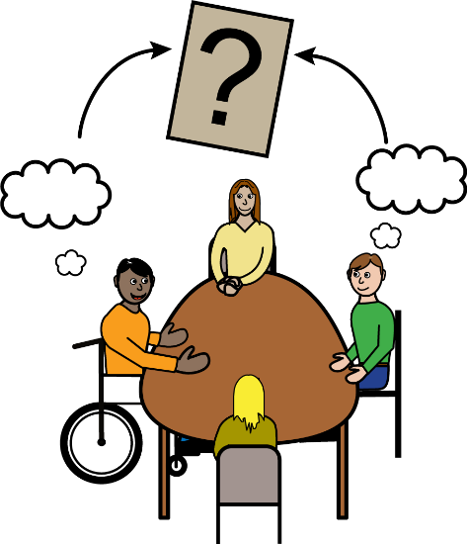 | - Find out more about how to make sure you and other people are getting the right medicine for your mental health.
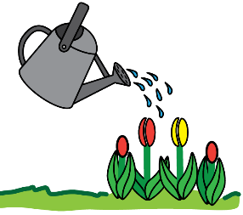  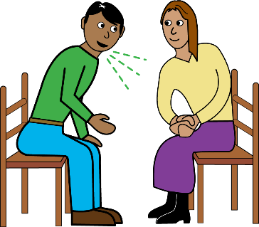 | - Find out about other things that might be good for your mental health
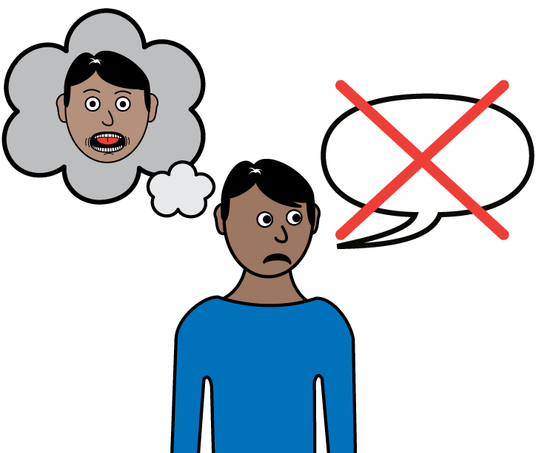 | - Tell us about your experiences of taking mental health medicines so we can help other people
 | - Tell us how you feel about asking for a medication review
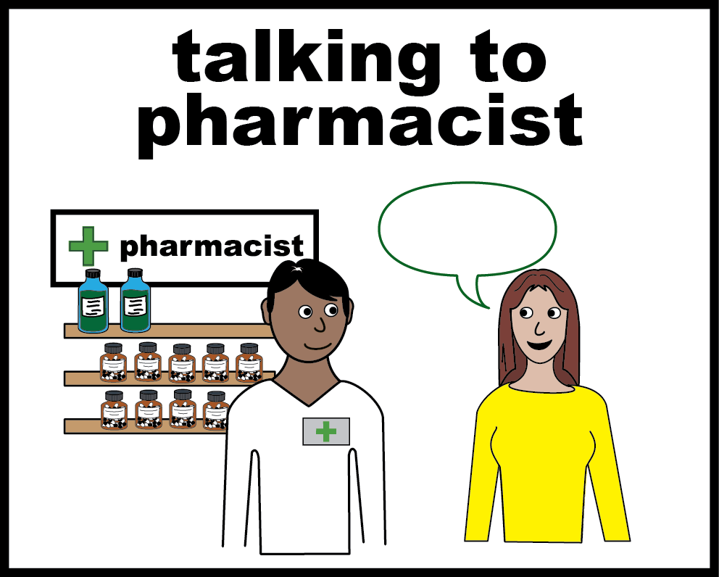 | - How to have a conversation if you are not happy with a decision around your care or medicine
 | - Find out more about the work we are doing to make sure people get the right medicine at the right time (the programme that works to do this is called STOMP and STAMP).
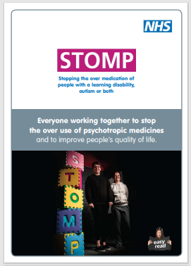 | If you want to find out more about our team you can view our leaflet here www.england.nhs.uk/wp-content/uploads/2018/02/stomp-easy-read-leaflet.pdf
The agenda for the day

 | We will be running two sessions at a time you can select which session you would like to go to at the bottom of this page.

9:30 – 10:00 |  | - Optional time to join the session early and get to know how to use teams
10:00 - 10:30 |  | - Welcome  - How to use teams  - Introduction to STOMP and STAMP  - Explaining the agenda of the day
10:30 - 11:15 |  | Drama workshop  OR  Art workshop
11:15 – 11:30 | 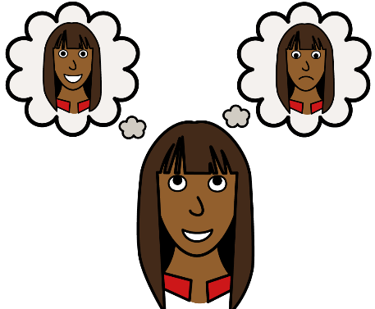 | feedback in the main room
11:30 – 11:45 | 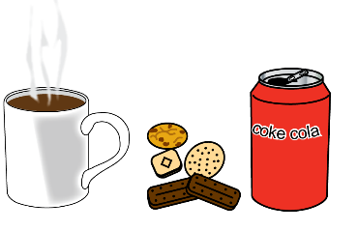 | Break
11:45 - 12:30 | 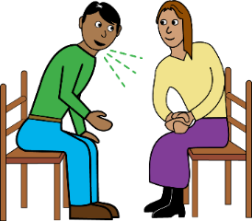 | Other options to medication  OR  Sharing our experiences
12:30 – 12:45 |  | feedback in the main room
12:45 - 1:45 |  | Lunch
1:45 - 2:30 | 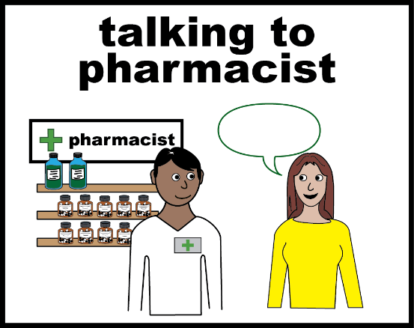 | Giving feedback, raising concerns and complaints  with Doctors and Pharmacists  OR  helping you stay calm
2:30 - 2:45 |  | feedback in the main room
2:45 - 3:30 |  | Feedback from the day and close.

 | If you would be interested in attending our event please fill out our questions below.
 | We will email you with the invite links a week before the event.
If you find this form difficult please let us know and we can support you to fill it in
Email us on england.wesupport.stomp@ nhs.net

Questionnaire
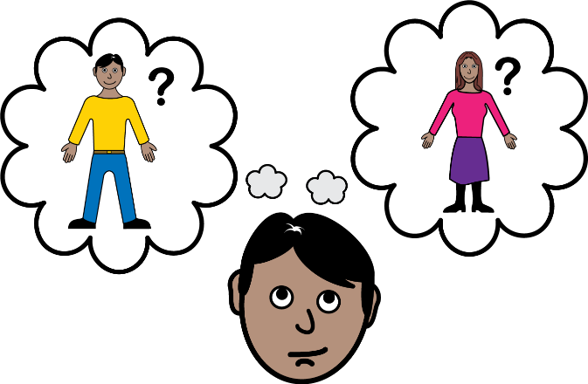 | Please tell us who you are
☐ I have a learning disability
☐ I am an autistic person
☐ I have a learning disability and am an autistic person
☐ I am a family carer
☐ I am a support worker attending with the person I support
☐ We are a group of people with a learning disability, autistic people and support workers who are joining the call together (on the same laptop, tablet or phone)
☐ Other Click or tap here to enter text.

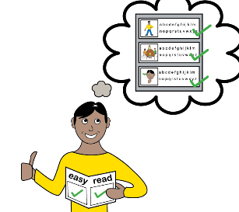 | If you need a reasonable adjustment to be able to join our event online, please write it bellow
Click or tap here to enter text.
 | Please tell us which workshops you would be most interested in going to:
☐ Drama Workshop | ☐ Art workshop
☐ Other options to medication | ☐ Sharing our experiences
☐ Having conversations with Doctors and Pharmacists | ☐ Mindfulness
 | Your contact details
Email:
Click or tap here to enter text.

Phone number:
Click or tap here to enter text.

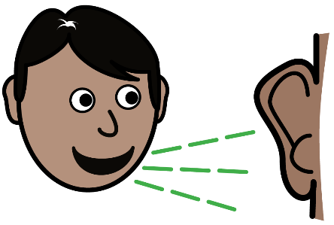 | Please tell us how you heard about the event
Click or tap here to enter text.
 | Do you have any other comments about the event?
Click or tap here to enter text.

