Directions to York House

NHS England - York House
18-20 Massetts Road
Horley, Surrey
RH6 7DE

Tel: 01293 778899
Fax: 01293 778888

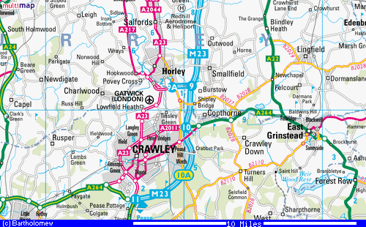
For a more detailed map visit the MultiMap Web site.

From M23 – take Junction 9 - Gatwick Airport
- Follow signs to Gatwick Airport and go straight across 1st roundabout following signs to Redhill.
- At the next roundabout take 4th exit, signposted Redhill
- At dual carriageway, take right hand lane and turn right at roundabout, following signs for Redhill and Horley.
- Take 2nd road on your right (Massetts Road), signposted Horley Town Centre,
York House is approximately 500 yards along on the left, (before you reach the traffic lights)
- Turn left immediately past York House, sign posted Short Stay Parking

From A 23
- From north of Horley on A 23, at large roundabout with Chequers Thistle on right, continue south on A23 towards Gatwick (ignore signs to Horley station).
- Continue straight on at traffic lights where Horley Town Centre is signposted to left. Take 3rd turning to left – Massetts Road and follow directions for York House above.
- From south of Horley on A23, at Longbridge roundabout near Gatwick, follow signs to Horley and Redhill.
- Take 2nd road on right (Massetts Road) signposted Horley Town Centre and follow directions for York House above.

Detailed Map – Horley Town Centre.

A23

Parking charges
Parking charges for pay and display car-park behind York House:
Car park opens 0800 – 1800 hours Monday to Friday
No change is given
Only coins accepted - 5p, 10p, 20p, 50p, £1, £2
Up to 40 mins parking: .20p
Up to 1 hr parking: .60p
Up to 2 hrs parking: £1.00p
Up to 3 hrs parking: £1.50p
Up to 4 hrs parking: £2.00p
Up to 5 hrs parking: £2.50p
Up to 6 hrs parking: £4.00p
Disabled badge holders - no charge

