NORTH REGIONAL
LEARNING DISABILITY AND AUTISM GOOD PRACTICE
EVENT

18 March 2019, Leeds
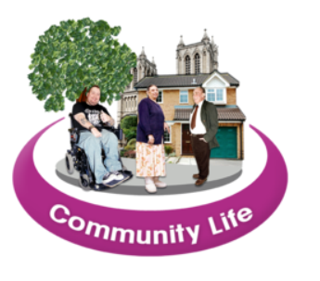 | We want to share good work about supporting people in the community.
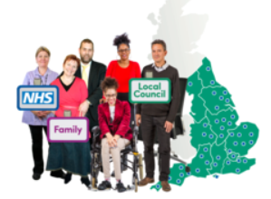 | This could be about different people working well together.
 | Or it could be about living a healthy life.
 | Or any other way that does things a bit differently!
 | Telling people about good work means they can learn from it.
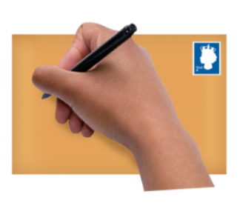 | You can book onto the event in the following ways.  Website  https://www.events.england.nhs.uk/events/north-regional-lives-transformed-good-practice-event  Phone 0113 824 8454  Email england.fasttracknorth@nhs.net  Address  Transforming Care Team  NHS England  6th Floor, Quarry House  Leeds, LS2 7UE

