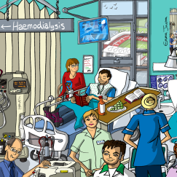
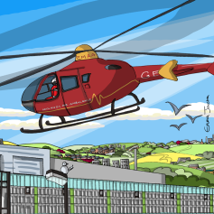

West Midlands Transplant Audit, QI and Education Event
4th July 2019 9:00-16:30
Banks’s Stadium, Walsall Football Club, Bescott Crescent, Walsall, WS1 4SA
An opportunity for clinicians, patients and commissioners to come together to share data, outcomes, experiences and learning around kidney transplantation
The programme includes (please note not finalised yet):
- Heated Debate: lets scrap cardiac tests for transplant listing
- Interactive case presentation and ‘terrify the expert’ session post-transplant care
- ABSTRACT/POSTER SESSIONS (see below)
- Transplant first and Living donor transplantation- moving forward with QI
- Review of the national, regional and local data for transplantation
Click here to book your place. A full agenda will be circulated in due course.
Posters-please submit titles of posters you wish to bring by 21st June
Oral presentations- please submit abstracts by 7th June. You will be notified if you are presenting by 14th June
Please submit both to sourabh.chand2@nhs.net.

