NATIONAL DYNAMIC PURCHASING SYSTEM
GENERAL PRACTICE SERVICES
INFORMATION FACTSHEET FOR GP PROVIDERS

This factsheet is for all General Practice (GP) providers who have ever considered and may be interested in providing GP services under Alternative Provider Medical Services (APMS) contracts, including caretaker arrangements.

NHS England and NHS Improvement is launching a new online procurement tool (known as a Pseudo Dynamic Purchasing System (PDPS)) where prospective GP providers will be listed and invited to provide APMS services when local needs arise. This system is planned to be live from January 2020.

This factsheet provides some more information about the PDPS, the benefits and how you can find out more information, including how to apply.

What APMS services are in scope?
There are two main “lots” to the APMS services currently planned in scope:

Lot 1. Routine GP services. This lot will be used to support local commissioners deliver on their procurement plans for replacing existing or securing additional GP services and covers the core list-based services expected from all GP practices in England.

The emphasis here is on meeting planned needs that are typically subject to full commissioning and procurement processes. APMS contracts will reflect the bespoke needs of each local commissioner.

Lot 2. Caretaker Services. These are the urgent cover arrangements, approved by primary care joint and commissioning committees, on a case by case basis, to ensure a safe and sustainable GP service continues for patients when a GP contract terminates suddenly or unexpectedly.

It is the case that the need for a caretaker to be secured is either urgent, from a matter of a few days to up to three/six months, where more notice is provided by the GP contractor. The cover arrangements usually last no longer than a year to allow longer term plans for meeting the ongoing general practice needs of patients to be developed, considered by commissioning committees and implemented.

NHS England and NHS Improvement has recently publicly consulted on proposals to create new opportunities for digital providers to set up new general practice services in the most under-doctored areas, using an APMS contract. The approach consulted on is outside of the scope of this PDPS, but this will be kept under review, subject to the outcome of the consultation. https://www.england.nhs.uk/wp-content/uploads/2019/06/digital-first-primary-care-consultation.pdf
The new purchasing system
The PDPS is being set up under the Light Touch Regime for Health Care contracts within the Public Contracts Regulations 2015. The system is being put in place by NELCSU (North and East London Commissioning Support Unit) on behalf of NHS England and NHS Improvement.

The PDPS is a 4-year procurement exercise being managed through a new e-procurement platform and will see:

- GP providers appointed to an electronically managed list of approved providers – GP providers can apply and be added to this list at any time during the 4-year period, unlike a traditional procurement framework.

- Approved GP providers invited via the e-platform to respond to requests for APMS services from local commissioners. This local “call off” will be matched to the bespoke needs of local commissioners.

To ensure the PDPS can be managed efficiently while also being sensitive to local commissioner (and provider) needs it is being broken down in to geographical lots
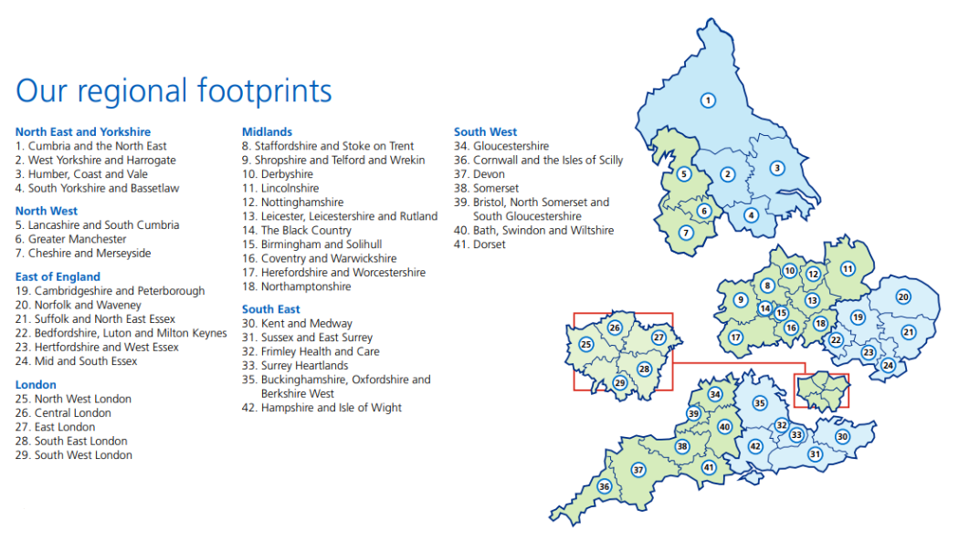
GP Providers will apply to be an approved APMS and/or caretaker provider in one (or more) of NHS England and NHS Improvement’s seven operating regions, also indicating (for information) which local areas within those regions they will be interested in providing services. These local area “sub-lots” mirror the System and Transformation Partnership (STP) areas covering the whole of England.

Why should I apply?
NHS England and NHS Improvement, and Clinical Commissioning Groups will be encouraging all GP providers with an interest in providing routine and/or caretaker APMS services to apply to be on the PDPS.

This interest could simply be as a local GP contract holder or lead contractor within a Primary Care Network, which could provide a one-off caretaker offer, for example, in the case of a neighbouring practice falling in to difficulty. This interest could also be from larger GP contract holders and other Healthcare providers, for example, those able to offer across a Primary Care Network, STP, Region or even nationally.

Application on to the approved provider list does not commit you to providing APMS services but does mean you will be able to bid when local needs arise.

Again, you can apply at almost any time (subject to the timing of future intake rounds) but we would like prospective providers to apply as early as possible from launch. You just need to apply once.

The PDPS will be agile and adaptable to the local caretaker provider market, for example, if a local commissioner made a direct caretaker award outside of the PDPS the provider will be able to join retrospectively and be able to then bid for future requirements.

What do I need to demonstrate to qualify as an approved provider?
Providers that meet the relevant eligibility criteria will be admitted onto the PDPS. Minimum threshold on suitability and capability will need to be met and key pass/fail questions will be asked of providers in the following areas:

- Financial and economic standing,
- Technical and professional ability
- Mandatory and discretionary exclusion questions
- Other subject matter questions.

Local commissioners will invite approved GP providers to bid on the local requirements only.

How do I apply
The PDPS is being set up under the Light Touch Regime for Health Care contracts within the Public Contracts Regulations 2015. A 4-year contract notice will be published in the European Journal. This is currently scheduled for early November.

It will be important to register on the e-platform here https://uk.eu-supply.com/login.asp?B=UK and closely monitor electronic communications when a service is being commissioned at Call-Off (Call for competition)

Where can I find out more?
NHS England and NHS Improvement is running a series of national engagement events that current and prospective GP providers are invited to attend to find out more. Parallel events are being held for commissioners.

Where | Date | Time
Horizon Leeds, 3rd Floor, 2 Brewery Wharf, Leeds, LS10 1JR | 23 October 2019 | 2.00pm-4.00pm
Edgbaston Stadium, Warwickshire Suite, Edgbaston, Birmingham West Midlands, B5 7QU | 28 October 2019 | 2.00pm-4.00pm
Ambassadors Bloomsbury Hotel, 12 Upper Woburn Place, Bloomsbury, London, WC1H 0HX | 30 October 2019 | 2.00pm-4.00pm

To book your attendance click on the event booking link here
NHS England and NHS Improvement
https://www.events.england.nhs.uk/national-dynamic-purchasing-system-events

Commissioners are not required to use the new system but we hope the streamlining benefits for both them and prospective providers speak for themselves.

